**Date Submitted: 10/29/19**

**Task 01:**

In this task, I am to receive and transmit the recorded temperature using the internal temperature sensor and then display it on the terminal. As seen below.

Youtube Link:

<https://www.youtube.com/watch?v=WAmjE39dqeM>

**Modified Schematic (if applicable):**

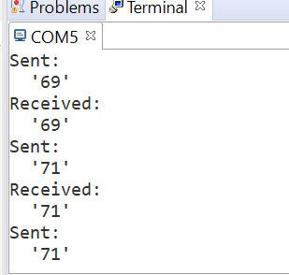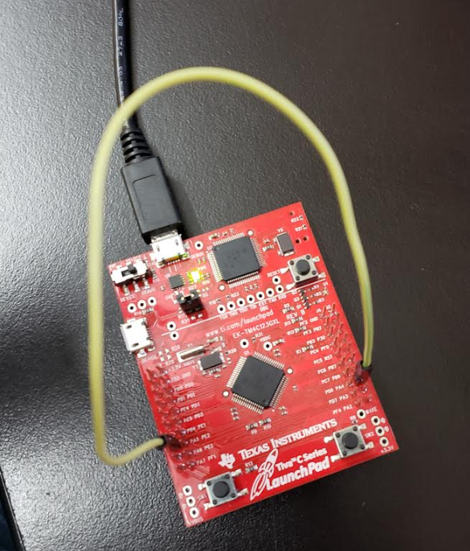

**Modified Code:**

**// Insert code here**

**#include** <stdbool.h>

**#include** <stdint.h>

**#include** "inc/hw_memmap.h"

**#include** "driverlib/gpio.h"

**#include** "driverlib/pin_map.h"

**#include** "driverlib/ssi.h"

**#include** "driverlib/sysctl.h"

**#include** "driverlib/uart.h"

**#include** "utils/uartstdio.h"

**#include** "driverlib/adc.h"

**#include** "driverlib/debug.h"

**#define** NUM_SSI_DATA 1

//*****************************************************************************

//

// This function sets up UART0 to be used for a console to display information

// as the example is running.

//

//*****************************************************************************

**void** **InitConsole**(**void**)

{

// Enable GPIO port A which is used for UART0 pins.

**SysCtlPeripheralEnable**(SYSCTL_PERIPH_GPIOA);

// Configure the pin muxing for UART0 functions on port A0 and A1.

// This step is not necessary if your part does not support pin muxing.

**GPIOPinConfigure**(GPIO_PA0_U0RX);

**GPIOPinConfigure**(GPIO_PA1_U0TX);

// Enable UART0 so that we can configure the clock.

**SysCtlPeripheralEnable**(SYSCTL_PERIPH_UART0);

// Use the internal 16MHz oscillator as the UART clock source.

**UARTClockSourceSet**(UART0_BASE, UART_CLOCK_PIOSC);

// Select the alternate (UART) function for these pins.

**GPIOPinTypeUART**(GPIO_PORTA_BASE, GPIO_PIN_0 | GPIO_PIN_1);

// Initialize the UARTfor console I/O.

**UARTStdioConfig**(0, 115200, 16000000);

}

//*****************************************************************************

//

// Configure SSI0 in master Freescale (SPI) mode. This example will send out

// 3 bytes of data, then wait for 3 bytes of data to come in. This will all be

// done using the polling method.

//

//*****************************************************************************

**int** **main**(**void**)

{

uint32_t pui32DataTx[NUM_SSI_DATA];

uint32_t pui32DataRx[NUM_SSI_DATA];

uint32_t ui32Index;

**SysCtlClockSet**(SYSCTL_SYSDIV_1 | SYSCTL_USE_OSC | SYSCTL_OSC_MAIN |SYSCTL_XTAL_16MHZ);

// Set up the serial console to use for displaying messages. This is

// just for this example program and is not needed for SSI operation.

InitConsole();

// The SSI0 peripheral must be enabled for use.

**SysCtlPeripheralEnable**(SYSCTL_PERIPH_SSI0);

// The SSI0 peripheral is on Port A and pins 2,3,4 and 5.

**SysCtlPeripheralEnable**(SYSCTL_PERIPH_GPIOA);

// This function/s configures the pin muxing on port A pins 2,3,4 and 5

**GPIOPinConfigure**(GPIO_PA2_SSI0CLK);

**GPIOPinConfigure**(GPIO_PA3_SSI0FSS);

**GPIOPinConfigure**(GPIO_PA4_SSI0RX);

**GPIOPinConfigure**(GPIO_PA5_SSI0TX);

// Configure the GPIO settings for the SSI pins. This function also gives

// control of these pins to the SSI hardware. Consult the data sheet to

// see which functions are allocated per pin.

// The pins are assigned as follows:

// PA5 -SSI0Tx

// PA4 -SSI0Rx

// PA3 -SSI0Fss

// PA2 -SSI0CLK

**GPIOPinTypeSSI**(GPIO_PORTA_BASE, GPIO_PIN_5 | GPIO_PIN_4 | GPIO_PIN_3 |GPIO_PIN_2);

// Configure and enable the SSI port for SPI master mode. Use SSI0,

//system clock supply, idle clock level low and active low clock in

// freescale SPI mode, master mode, 1MHz SSI frequency, and 8-bit data.

// For SPI mode, you can set the polarity of the SSI clock when the SSI

// unit is idle. You can also configure what clock edge you want to

// capture data on. Please reference the datasheet for more information on

// the different SPI modes.

**SSIConfigSetExpClk**(SSI0_BASE, **SysCtlClockGet**(), SSI_FRF_MOTO_MODE_0,SSI_MODE_MASTER, 1000000, 8);

// Enable the SSI0 module.

**SSIEnable**(SSI0_BASE);

//Variables for Temperature

uint32_t ui32ADC0Value[4];

**volatile** uint32_t ui32TempAvg;

**volatile** uint32_t ui32TempValueC;

**volatile** uint32_t ui32TempValueF;

//Set system clock

**SysCtlClockSet**(SYSCTL_SYSDIV_5|SYSCTL_USE_PLL|SYSCTL_OSC_MAIN|SYSCTL_XTAL_16MHZ);

//Enable ADC

**SysCtlPeripheralEnable**(SYSCTL_PERIPH_ADC0);

//Configure all four steps of ADC sequencer

**ADCSequenceConfigure**(ADC0_BASE, 1, ADC_TRIGGER_PROCESSOR, 0);

**ADCSequenceStepConfigure**(ADC0_BASE, 1, 0, ADC_CTL_TS);

**ADCSequenceStepConfigure**(ADC0_BASE, 1, 1, ADC_CTL_TS);

**ADCSequenceStepConfigure**(ADC0_BASE, 1, 2, ADC_CTL_TS);

//Configure interrupt flag = ADC_CTL_IE

//Tell ADC logic that this is the last conversion on sequencer

**ADCSequenceStepConfigure**(ADC0_BASE,1,3,ADC_CTL_TS|ADC_CTL_IE|ADC_CTL_END);

//Enable ADC sequencer 1

**ADCSequenceEnable**(ADC0_BASE, 1);

**while**(1)

{

//clear interrupt flag

**ADCIntClear**(ADC0_BASE, 1);

//trigger ADC conversion with software

**ADCProcessorTrigger**(ADC0_BASE, 1);

//wait for conversion

**while**(!**ADCIntStatus**(ADC0_BASE, 1, false))

{

}

//get data from a buffer in memory

**ADCSequenceDataGet**(ADC0_BASE, 1, ui32ADC0Value);

//temperature calculations

ui32TempAvg = (ui32ADC0Value[0] + ui32ADC0Value[1] + ui32ADC0Value[2] + ui32ADC0Value[3] + 2)/4;

ui32TempValueC = (1475 - ((2475 * ui32TempAvg)) / 4096)/10;

ui32TempValueF = ((ui32TempValueC * 9) + 160) / 5;

// The "non-blocking" function checks if there is any data in the receive

// FIFO and does not "hang" if there isn't.

**while**(**SSIDataGetNonBlocking**(SSI0_BASE, &pui32DataRx[0]))

{

}

// Initialize the data to send.

pui32DataTx[0] = ui32TempValueF;

**SysCtlDelay**( (**SysCtlClockGet**()/(3*1000))*1000 ) ;

// Display indication that the SSI is transmitting data.

**UARTprintf**("\nSent:\n ");

// Send 3 bytes of data.

**for**(ui32Index = 0; ui32Index < NUM_SSI_DATA; ui32Index++)

{

// Display the data that SSI is transferring.

**UARTprintf**("'%u' ", pui32DataTx[ui32Index]);

// Send the data using the "blocking" put function. This function

// will wait until there is room in the send FIFO before returning.

// This allows you to assure that all the data you send makes it into

// the send FIFO.

**SSIDataPut**(SSI0_BASE, pui32DataTx[ui32Index]);

}

// Wait until SSI0 is done transferring all the data in the transmit FIFO.

**while**(**SSIBusy**(SSI0_BASE))

{

}

**SysCtlDelay**( (**SysCtlClockGet**()/(3*1000))*1000 ) ;

// Display indication that the SSI is receiving data.

**UARTprintf**("\nReceived:\n ");

// Receive 3 bytes of data.

**for**(ui32Index = 0; ui32Index < NUM_SSI_DATA; ui32Index++)

{

// Receive the data using the "blocking" Get function. This function

// will wait until there is data in the receive FIFO before returning.

**SSIDataGet**(SSI0_BASE, &pui32DataRx[ui32Index]);

// Since we are using 8-bit data, mask off the MSB.

pui32DataRx[ui32Index] &= 0x00FF;

// Display the data that SSI0 received.

**UARTprintf**("'%u' ", pui32DataRx[ui32Index]);

}

}

// Return no errors

**return**(0);

}

**------------------------------------------------------------------------------------**

**Task 02:**

In this task, I interfaced with the WS2818B 1x8 RGB LED strip with the TIVAC using SPI interface. It will light up R, G, B, RG, RB, GB, RGB.

Youtube Link:

<https://www.youtube.com/watch?v=V0ovQtnTGk4>

**Modified Schematic (if applicable):**

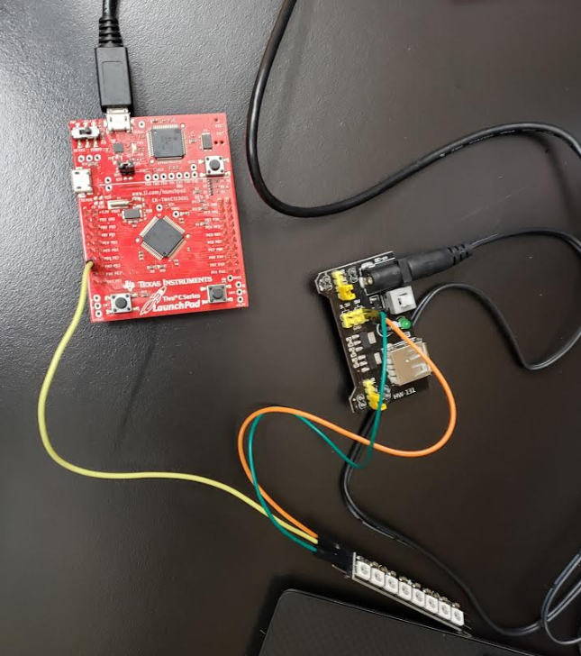

**Modified Code:**

**#include** <stdbool.h>

**#include** <stdint.h>

**#include** "inc/hw_memmap.h"

**#include** "inc/hw_types.h"

**#include** "driverlib/gpio.h"

**#include** "driverlib/pin_map.h"

**#include** "driverlib/ssi.h"

**#include** "driverlib/sysctl.h"

**#include** "driverlib/uart.h"

**#include** "utils/uartstdio.h"

**#include** "driverlib/adc.h"

**#include** "driverlib/debug.h"

**#define** NUM_LEDS 8

uint8_t frame_buffer[NUM_LEDS*3];

**void** **send_data**(uint8_t* data, uint8_t num_leds);

**void** **fill_frame_buffer**(uint8_t r, uint8_t g, uint8_t b, uint32_t num_leds);

**static** **volatile** uint32_t ssi_lut[] = {

0b100100100,

0b110100100,

0b100110100,

0b110110100,

0b100100110,

0b110100110,

0b100110110,

0b110110110

};

**int** **main**(**void**) {

FPULazyStackingEnable();

// 80MHz

**SysCtlClockSet**(SYSCTL_SYSDIV_2_5 | SYSCTL_USE_PLL | SYSCTL_XTAL_16MHZ |

SYSCTL_OSC_MAIN);

//initialize SPI

**SysCtlPeripheralEnable**(SYSCTL_PERIPH_GPIOA);

**SysCtlDelay**(50000);

**SysCtlPeripheralEnable**(SYSCTL_PERIPH_SSI0);

**SysCtlDelay**(50000);

**GPIOPinConfigure**(GPIO_PA5_SSI0TX);

**GPIOPinConfigure**(GPIO_PA2_SSI0CLK);

**GPIOPinConfigure**(GPIO_PA4_SSI0RX);

**GPIOPinConfigure**(GPIO_PA3_SSI0FSS);

**GPIOPinTypeSSI**(GPIO_PORTA_BASE, GPIO_PIN_5);

**GPIOPinTypeSSI**(GPIO_PORTA_BASE, GPIO_PIN_2);

**GPIOPinTypeSSI**(GPIO_PORTA_BASE, GPIO_PIN_4);

**GPIOPinTypeSSI**(GPIO_PORTA_BASE, GPIO_PIN_3);

//20 MHz data rate

**SSIConfigSetExpClk**(SSI0_BASE, 80000000, SSI_FRF_MOTO_MODE_0, SSI_MODE_MASTER, 2400000, 9);

**SSIEnable**(SSI0_BASE);

**while**(1)

{

// Red

fill_frame_buffer(255, 0, 0, NUM_LEDS);

send_data(frame_buffer, NUM_LEDS);

**SysCtlDelay**(**SysCtlClockGet**()/5);

// Green

fill_frame_buffer(0, 255, 0, NUM_LEDS);

send_data(frame_buffer, NUM_LEDS);

**SysCtlDelay**(**SysCtlClockGet**()/5);

// Blue

fill_frame_buffer(0, 0, 255, NUM_LEDS);

send_data(frame_buffer, NUM_LEDS);

**SysCtlDelay**(**SysCtlClockGet**()/5);

// RG

fill_frame_buffer(255, 255, 0, NUM_LEDS);

send_data(frame_buffer, NUM_LEDS);

**SysCtlDelay**(**SysCtlClockGet**()/5);

// RB

fill_frame_buffer(255, 0, 255, NUM_LEDS);

send_data(frame_buffer, NUM_LEDS);

**SysCtlDelay**(**SysCtlClockGet**()/5);

// GB

fill_frame_buffer(0, 255, 255, NUM_LEDS);

send_data(frame_buffer, NUM_LEDS);

**SysCtlDelay**(**SysCtlClockGet**()/5);

// RGB

fill_frame_buffer(255, 255, 255, NUM_LEDS);

send_data(frame_buffer, NUM_LEDS);

**SysCtlDelay**(**SysCtlClockGet**()/5);

}

}

**void** **send_data**(uint8_t* data, uint8_t num_leds)

{

uint32_t i, j, curr_lut_index, curr_rgb;

**for**(i = 0; i < (num_leds*3); i = i + 3) {

curr_rgb = (((uint32_t)data[i + 2]) << 16) | (((uint32_t)data[i + 1]) << 8) | data[i];

**for**(j = 0; j < 24; j = j + 3) {

curr_lut_index = ((curr_rgb>>j) & 0b111);

**SSIDataPut**(SSI0_BASE, ssi_lut[curr_lut_index]);

}

}

**SysCtlDelay**(50000); // delay 50us

}

**void** **fill_frame_buffer**(uint8_t r, uint8_t g, uint8_t b, uint32_t num_leds)

{

uint32_t i;

uint8_t* frame_buffer_index = frame_buffer;

**for**(i = 0; i < num_leds; i++) {

*(frame_buffer_index++) = g;

*(frame_buffer_index++) = r;

*(frame_buffer_index++) = b;

}

}

**------------------------------------------------------------------------------------**